GG Young Adult Retreat Schedule
Goretti Group Mission Statement
The Goretti Group is a movement for people of all ages and states in life committed to living and spreading the joy of pure love. Goretti Group members seek to discover God’s plan for human sexuality and explore the richness of revealed truth, thus discovering their true identity as children of God: “God created man in His own image; in the image of God He created him; male and female He created them.” (Genesis 1:27)
Friday Night
3:00pm – Arrivals begin
4:30pm – Pick-up at Poughkeepsie train station (Amtrak & Metro North)
5:00pm – Dinner in Dining Room (Lower Level)
6:00pm – Welcome/ Introductions/ Walk & explore
7:00pm – Icebreakers in 1st Floor Conference Room
7:30pm – Small Group – Dating Tips (lounges/reading room)
8:00pm – Meditation – Bible Verses – Enter Silence
9:00pm –Night Prayer in St. Mary of the Angels 3rd Floor Chapel (optional)

Saturday
8:00am – Breakfast in Dining Room (Lower Level)
8:00am – Optional Mass in Church (1st Floor)
9:00am – Talk #1: Holy Eucharist: The Saints Greatest Treasure
and How Jesus Pursues Us (Patrick O’Hearn)
Personal Time for Reflection Questions
10:00am – Small Group Sharing (Lounges/Reading Room)
10:30am – Breakout Discussion Session Activities
11:30am – Free Time (journal writing, personal prayer, rest)
12:00 Noon - Lunch in Dining Room (Lower Level)
1:00pm – Free time for walks/personal prayer/etc.
1:15pm- Talking about Pornography/Alessandro S.
Female/Male Small Group Discussion (lounges/reading room)
2:00pm – Adoration & Confession in Church (until 4pm)
3:00pm Optional Chastity Stations of the Cross (outdoor
stations- meet in Conference Rm 2 on 1st Floor)
4:00pm – Talk #2 Virtuous Leadership - From Temperament to
Character - Nicholas Masquelier
5:00pm – Dinner in Dining Room (Lower Level)
6:00pm – Talk #3: Courtship of the Saints: The Virtues Necessary to Finding Your Spouse (Patrick O’Hearn)
Personal Time for Reflection Questions (Conf. Rm #1)
7:00pm – Small Group Sharing (Lounges/Reading Room)
7:30pm – Free Time (journal writing, personal prayer, rest)
7:40pm - Rosary (optional) in 3rd Floor Chapel?
8:00pm – Fireside Night Prayer (Bonfire/Praise & Worship/S’mores/Dance (music?) (large parking lot) (optional)

Sunday
Wake up – 7:50am – Pack-up/Room maintenance
8:00am – Breakfast in Dining Room (Lower Level)
8:30am - Morning Prayer & Private Reflection (3rd Fl Chapel)
9:00am - Small Group Sharing (Gospel/Retreat take-
aways/evaluations)
9:45am - Free Time/Personal/Gift shop
10:00am – Mass (Main Church)
11:00am – Large Group Share - Summary of Small Groups
11:30-12 Noon – Departure
12 Noon – Rides to train station

Speaker Bio’s on the next Page!

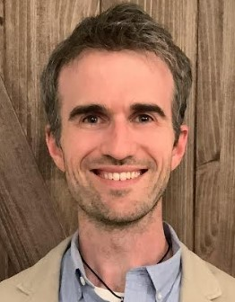
Patrick O'Hearn -
Talk #1: Holy Eucharist: The Saints Greatest Treasure
and how Jesus Pursues us (Patrick O'Hearn)
Talk #2 : Courtship of the Saints: The Virtues Necessary to Finding Your Spouse
Patrick is a devout Catholic, husband, and father. He has two children on earth and two children in heaven. He is an author, literary consultant, speaker, and a freelance editor, previously serving as TAN Books' acquisitions editor for two years. He has authored seven books including Courtship of the Saints: How the Saints Met their Spouses. He also was a contributor to Fr. Calloway's latest release: 30 Day Eucharistic Revival: A Retreat with St. Peter Eymard.
He grew up in the Midwest and spent close to three years in a Benedictine Monastery before discerning the call to marriage. He graduated with a master's in education from Franciscan University of Steubenville and a bachelor's in marketing from St. Ambrose University.
--------------------------------------------------------------------------------------------------------------------
Virtuous Leadership - From Temperament to Character
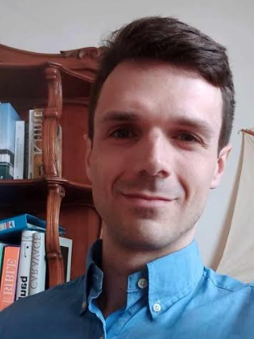
Nicolas Masquelier
The Virtuous Leadership, developed by Alexandre Havard, aims at the greatness and fulfillment of the human person.
During our talk/training, we will begin with an analysis of temperaments to discover how to build our character through the practice of virtues (virtue challenge related to your temperament but also virtues of prudence, courage, justice, self-mastery, humility, and magnanimity).
Why? It will help you to:
1) Better understand yourself;
2) Better understand and comprehend others;
3) Developing your character will help you to become a better person and, without a doubt, attract that desired virtuous spouse ;)

Nicholas Masquelier
Nicolas, 30 years old, from Brussels (a city in that distant European country: Belgium), practicing Catholic, studied Human Resources Management at university, and currently working as an HR Manager for an organization employing 300 people.
He became a trainer focusing on subjects related to Human Resources Management (management, labor law, etc.).
Convinced by the model of virtuous leadership, he contributes his free time to the Belgium institute, particularly by speaking at seminars, training sessions, and workshops. He is convinced this talk will help you progress in your life and improve your human interactions.

